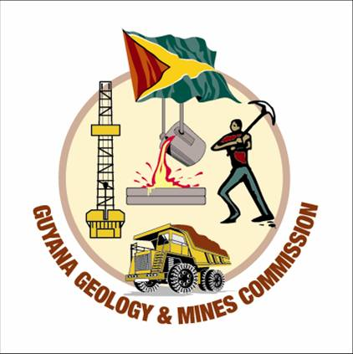

PUBLIC NOTICE
In keeping with our commitment to always better serve you, the Guyana Geology & Mines Commission wishes to advise new customers:
That pursuant to requirements, when conducting business with the Commission, the following documents must be presented before any transaction can be completed:
- Valid form of Identification (ID Card/ Passport/Driver’s Licence.
- Proof of Address (valid within 6 months). For further clarification visit https://eservices.ggmc.gov.gy/Account/Login?ReturnUrl=%2F for the recommended list of documents accepted as proof of address.
- TIN Certificate.
- Operational Telephone Number (An email address is recommended but optional once a telephone number can be reached).
For Existing Customers:
At this time, existing customers are kindly requested to visit the Commission’s Head Quarters at 44 High & Princes St. Georgetown or Sub-Stations to update your details, ensuring the 6-month validity is maintained. You can also access the GGMC’s website https://eservices.ggmc.gov.gy/Customer/CustomerForm and complete the online form, ensuring that your details are correctly uploaded and submitted.
The Commission would like to thank our customers for their usual support in these matters.

Newell M. Dennison
Commissioner, GGMC

